Minutes of Meeting held on 3rd March 2022

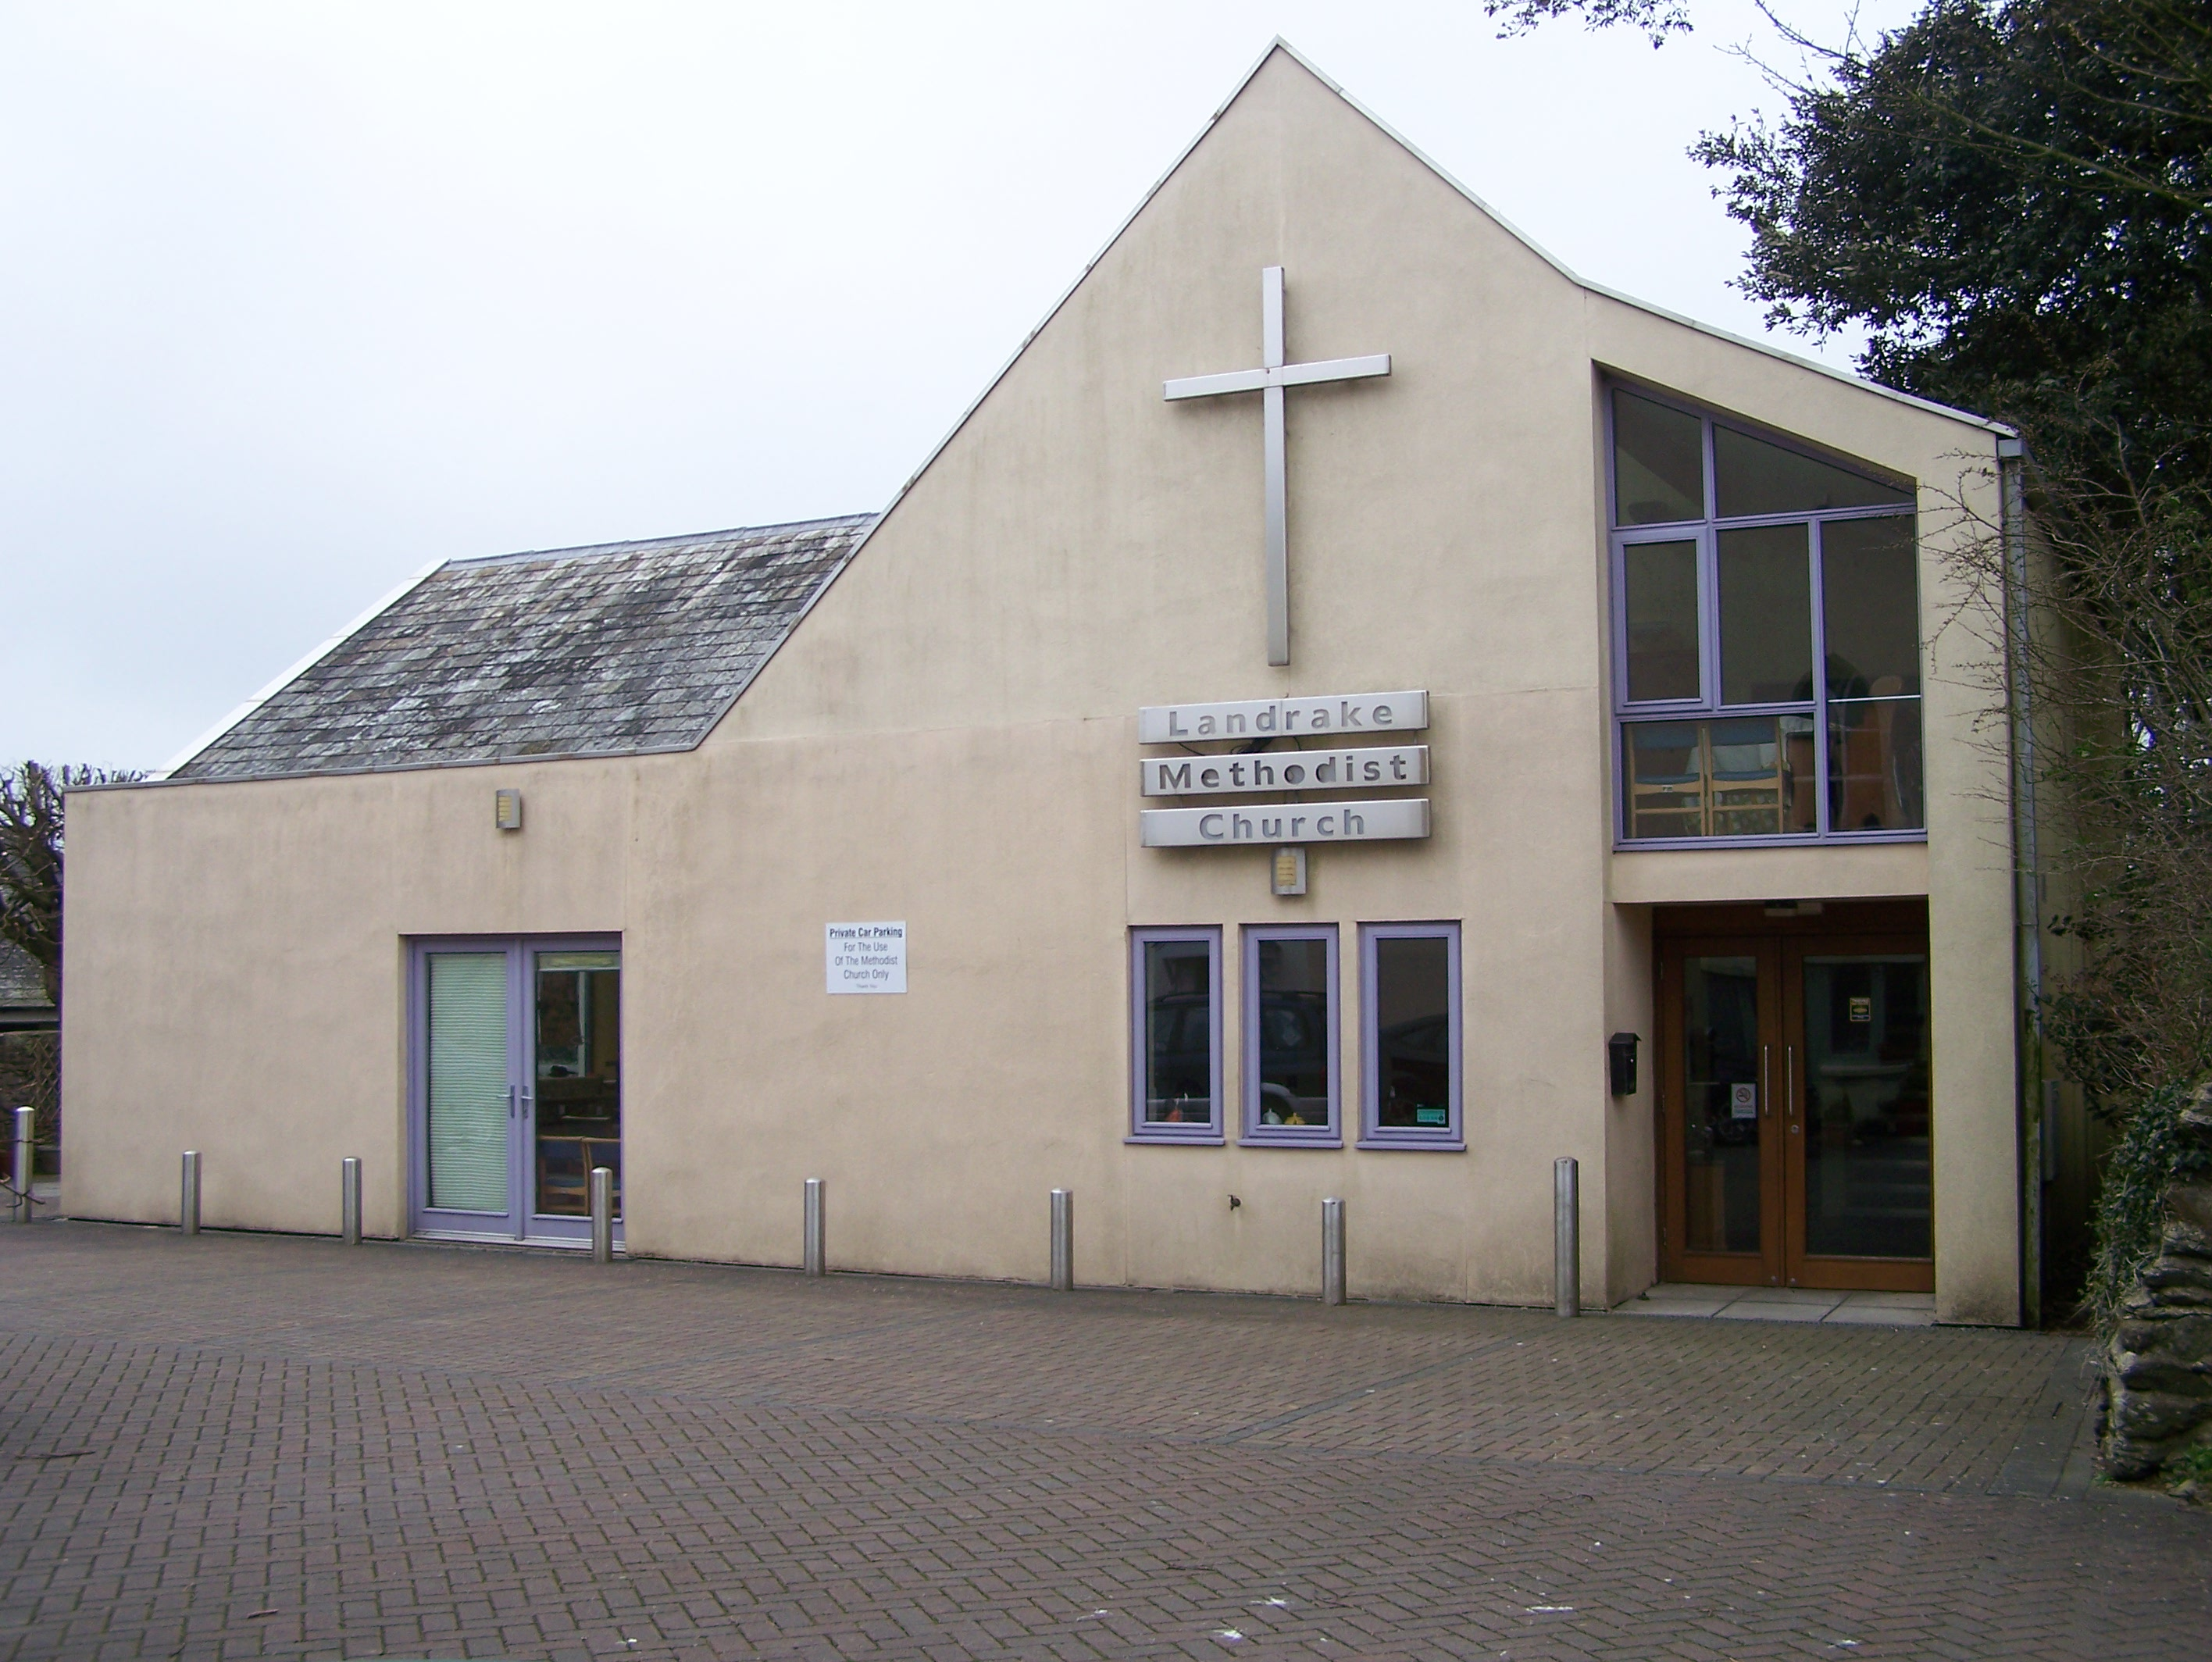

Table of Contents
Page No:
Those Present: 1
Opening Devotions: 1
Apologies: 1
Minutes of Last Meeting: 1
Matters Arising from the previous meeting: 1
Circuit Development: Linda reported w 1
Safeguarding: 1
Membership and Pastoral: 1
Finance: 1
GDPR: 2
Future Plans: 2
Anniversary Service: 2
Planned Service 8th May: 2
Property Report: 2
Church Organ: 2
Date of Next Meeting 2

Landrake Methodist Church

Minutes of the Church Council held on 3rd March 2022

Those Present: Revd Iris Bray (Chair), Linda Eastlake (CLT), Evon Roberts (Treasurer with Oversight), Sheena Lawson, Hazel Cartledge-Claus, Phyllis Sweet, Paul Fry (Secretary).

Opening Devotions: Revd Iris welcomed everyone and opened the meeting opened with a reading Isaiah Chapter 43 commencing at verse 9.

Apologies: Jenny Biddulph, Cora Alford

Minutes of Last Meeting:

The previous minutes 27th January 2022 were accepted and signed by Revd. Iris after an amendment.
Matters Arising from the previous meeting: None

Circuit Development: Linda reported with the loss of a ministerial post from the circuit, the circuit meeting will discuss ways in which we can celebrate the sacrament. Sheena gave her apologies for the next circuit meeting.

Safeguarding:
Foundation and Advanced training will commence on 2nd April. As Sheena has already attended the Foundation course Rev Iris will report back if Advanced training is required.
Key holders have already signed Safeguarding Form “D”; it is not understood if DBS checks are also required. Rev Iris to bring it to the Circuit Safeguarding Team for advice.
Membership and Pastoral:
Rev Iris reported that she has given a Pastoral list to Rev Jonathan to cover her Sabbatical.
Finance:
- Rev Iris reported that our new Assessment will be set at £981.30 per quarter.
- The meeting agreed that Paul pays our 2nd assessment of the year of £979.00
Property:
The Marriage Registers have been closed and one copy has been taken to Launceston Registry Office (GRO). The second register remains in the safe until decision is made to submit to the Cornwall Archive Office.
Discussions concerning the document “God in Love Unites Us” is to be deferred to another meeting.
GDPR:
GDPR deadline for us to meet our commitments is the end May 2022. Rev Iris completed the Data Mapping form with Trustees at the meeting. Rev Iris issued Data Collection Consent forms to members for completion by Sunday 6th March 2022. This will form the Landrake Consent Record which Rev Iris will sign off after completion. Phyllis Sweet has requested that her details are not to be recorded and removed from the Office record.
Future Plans:

Rev Iris reported that Blunts has declined our request to join together with them. The membership considered the original proposal to join with Burraton. Following discussion the meeting voted for each member to transfer membership to another Methodist church of the individual’s choosing. Proposed by Sheena, Seconded by Paul, All agreed.
Subsequent to this decision the Circuit Meeting will be invited to take Managing Trustee responsibility for the property. Landrake representatives at the Circuit Meeting on 22/03/22 will be invited to support this action by presenting the flourishing outreach work. Hazel stated that Messy Church has approximately 20 to 25 attending, the Monday Gang has about 15, the Community Café frequently has all the tables occupied, and the parent and toddler group has about 6 parents with children. Hazel reported that the sense of goodwill that the outreach work continue is supported as an anonymous donor has offered to purchase a new oven
Rev Iris stated once the Circuit Meeting has made its decision an inventory of items for sharing with others may be compiled.
Rev Iris suggested that we hold a celebration service at the end of July 2022.
Anniversary Service: 6pm, 5th June 2022. Paul confirmed that Terry Coneybeare and friends will take this service. No service to be planned for 9:30am.

Planned Service 8th May: Paul reported email communication with Revd Jonathan regarding Steve Wherly’s offer to take the service on 8th May. For a number of reasons, Revd Jonathan has responded his desire the Plan is followed as published. Paul to inform Steve and include Revd Jonathan in the email.

Property Report:

Church Organ:
Post meeting note - The contact in Bath who was going to carry out the repairs has still not been in touch.

Date of Next Meeting

The date of the next Church Council meeting TBC

Hazel prayed for Rev Iris as she related to us that she will be joining the St Austell circuit.

The meeting concluded at 4:20pm with the Grace.

